ERD and Assumptions

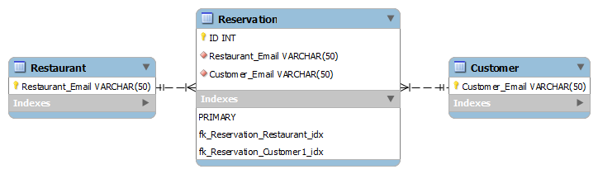

* A restaurant can have many reservations.
* A Customer can book many reservations.
* Instead of using ID’s for customer and restaurant, Email will be used as it’s unique.
* Each restaurant has an account specific to that one restaurant in that (Portsmouth) area.
  + So, a chain of restaurants, will all have different accounts.
  + They will not share accounts.
* There is no need for a cuisine table as it will be stated in the Restaurant table.
  + It will also be an option available to the Restaurant User in the form of a custom listed drop down.
* There is also no need for an Area table as it will also be stated in the Restaurant table.
  + It will also be an option available to the Restaurant User in the form of a custom listed drop down.
* The Restaurant will need to establish the number of Seats they have available, instead of tables due to the fact that it makes it easier for a Restaurant to plan their room arrangements.
* The value ‘Booked_Seats’ will need to be included to ensure that they can work out how much space is available for Reservations to be accepted.